y
Community Pharmacy Tracker and key tasks September 2026
April 2026
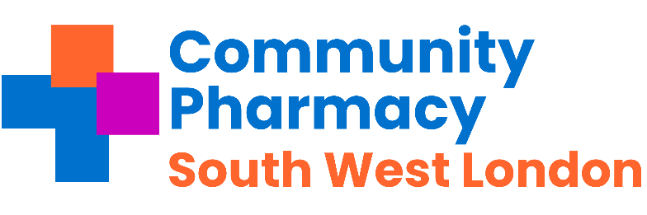

Pharmacies across Southwest London - important messages to share with your teams this week and any necessary actions.
Subject | Requirement | Deadline | Action and links | Tick when completed
Flu (Childhood) | Pharmacy Income | 30th September 2026 | Pharmacy owners must have registered by 11.59pm on the MYS portal to receive vaccine ahead of the commencement date of the service (1st October 2026)  Find out more here
PQS changes | Pharmacy Income | 31st December | The Palliative and End of Life Care questionnaire (PEoLC) will be published on the NHSBSA website. Pharmacies must complete this gateway criterion by the end of 31st December 2026 to be able to claim PQS.
PQS changes | Pharmacy Income |  | The clinical services audit will be published on the NHSBSA website and the window to complete will open.
Online NHS Profile Update | Contractual | Quarterly by 30th September | MUST DO Make sure you have updated your NHS profile with Flu and Covid vaccination services as appropriate. Remember to add any new services such as flu and covid vaccinations. Make sure you verify ALL 5 sections. Profile Manager.

Regular Tasks The following tasks need to be completed on a daily / monthly basis:
Subject | Requirement | Deadline | Action and links | Tick when completed
Service payment claim tracker | Pharmacy income | Monthly | Community Pharmacy England has created a payment timetable and deadline tracker to assist pharmacy owners with checking and claiming payments for the following services: The link is here
Reminder  Pharmacy First -Thresholds | Pharmacy Income | Monthly | - £500 for those providing 20-29 Clinical pathways consultations within a month; and  - £1000 for those pharmacies that provide 30 or more Clinical pathways consultations within a month.  Action: check NHSBSA website to see what your cap is for this month early in week 3 or 4 of each month.
Online Profile Update using NHS Profile Manager | Contractual | Quarterly | Ensure the DoS and NHS.uk website pharmacy profile is comprehensive and accurate by updating via the NHS Profile Manager. Verify and where necessary, update the information contained in the profile at least once each quarter. The financial quarters are:  - 1st April to 30th June  - 1st July to 30th September  - 1st October to 31st December  - 1st January to 31st March  Reminder of the new NHS Profile Manager tool for updating DoS & NHS website.  Note the NHS Terms of Service require pharmacy owners to check that their opening hours, contact information, facilities and services information are up to date for each profile, each financial quarter.  Check that each module is marked as verified, even if no change is required to the information. All boxes must be ticked in the NHS profile Manager otherwise, it will be marked as incomplete. The facilities section is the most often missed profile for confirmation,
Pharmacy Services Platforms | Information & Support | Now | Check that pharmacy staff have access to PharmOutcomes during all opening times, especially when locums are on duty; set-up additional accounts if needed. Instructions can be found here.’ Please ensure PharmOutcomes is checked regularly throughout the day (minimum 3 times a day) and action any referrals received for the following services:  - The Pharmacy First Service  - The Discharge Medicines Service  - The Hypertension Case Finding  - The Contraception Service  - The Smoking Cessation service
Serious Shortage Protocols (SSPs) | Dispensing | Ongoing | Active SSPs Can be found here.
MHRA Drug Safety Newsletter | Dispensing | Monthly | Download the monthly newsletter here
Drug Tariff | Dispensing | Monthly | Updates on the drug tariff can be found here
Temporary Suspensions/ Closures | Contractual | Ongoing | From 1 June 2026, the Manage Your Service (MYS) will be the only route to notify ICBs of temporary suspensions/closures  Find out more here | Change deadline
Local Services  (Local authority & ICB services) | Act now | By the  5th | Please claim all your locally commissioned services by  the 5th of the month.
Contact details | LPC | Ongoing | The LPC encourages Contractors, Pharmacy Superintendents , responsible pharmacy managers and locums to join the LPC mailing list and borough Whattapp groups to ensure they are up to date with the changes.  Please update your contact details LPC Contact and Pharmacy database update – Fill out form

Annual national campaigns for all national campaigns including health campaigns – please go here- Note these events are not contractual. -

Health Campaigns for July 2026
Know Your Numbers Week | 7-13 September 2026 | Encouraging adults to know their blood pressure numbers and take the necessary action to reach and maintain a healthy blood pressure.  Know your numbers
World Pharmacists Day | 25 September 2026 | A day to recognise and celebrate the crucial role that pharmacists play in building healthier communities everywhere. World Pharmacists Day

