y
Community Pharmacy Tracker and key tasks
March 2026
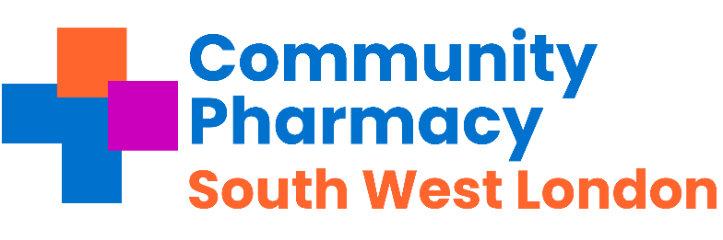

Pharmacies across Southwest London - important messages to share with your teams this week and any necessary actions.
Subject | Requirement | Deadline | Action and links | Tick when completed
Pharmacy First | Pharmacy Income | March | The activity threshold of clinical pathway consultations is 30 per month. This means you need to provide a minimum of 30 consultations that pass the gateway point to be eligible for the  £1,000 monthly payment (or 20+ for £500).  Check the NHSBSA website to see what your Pharmacy First cap is for this month.
PQS: The  Antimicrobial Stewardship | Contractual | 1st Sept 2025 – 31st  Mar 2026 | Pharmacy First consultations clinical audit can be started from the 1st September 2025  The 2025/26 clinical audit should be conducted from 1st September 2025 and completed no later than 31st March 2026
Community Pharmacy pressures survey | Information & Support | 11:59pm on 16th March 2026 | Community Pharmacy England's (CPE) Pressures Survey is currently underway and we are urging community pharmacy owners and pharmacy team members across SW London to help CPE quantify financial constraints  There are two separate surveys: one for pharmacy business owners/head office representatives and one for pharmacy teams. The surveys are open until 11:59pm on 16th March 2026. For more information and to complete either surveys, click here.
Lateral Flow Device (LFD) Myth busting Series | Contractual | Available Now | View the series that tackles some the misconceptions around the LFD service View here
Category H guidance | Income | February | Please read the guidance on Category H
Oriel Registration for 27/28 | Information & Support | 3rd March | Pharmacies need to register on Oriel if you want to host a trainee pharmacist for 27/28. More information
Flu Vaccination Services | Information & Support | 31st March | Both the Adult and Children’s flu vaccination services end.
Covid Vaccination Service | Information & Support | 10th March | Federated Data Platform (FDP) drop-in session for those taking part in the spring COVID-19 vaccination programme. Pharmacies will require access to FDP to order COVID-19 vaccines.
Healthy Living Pharmacy Requirement | Contractual | 31st March | Deadline for undertaking a community engagement exercise (at least one must be undertaken per financial year) on the promotion of healthy living.
Annual Complaints Report | Contractual | April | Make sure information is collated and ready to submit. The ICB will provide details on how to submit.

Regular Tasks The following tasks need to be completed on a daily / monthly basis:
Subject | Requirement | Deadline | Action and links | Tick when completed
Service payment claim tracker | Pharmacy income | Monthly | Community Pharmacy England has created a payment timetable and deadline tracker to assist pharmacy owners with checking and claiming payments for the following services: The link is here
Reminder  Pharmacy First -Thresholds | Pharmacy Income | Monthly | - £500 for those providing 20-29 Clinical pathways consultations within a month; and  - £1000 for those pharmacies that provide 30 or more Clinical pathways consultations within a month.  Check activity early in week 3 or 4 of each month.
Check NHS Shared Mailbox | Pharmacy Business | Twice a day -minimum | NHSE&I and CPSC regularly send important communications to your NHS Shared Mailbox.  Please ensure at least 2 members of staff have access your Mailbox and that it is checked at least twice a day.  Please see advice here.
Online Profile Update using NHS Profile Manager | Contractual | Quarterly | Using the ,NHS Profile Manager ensure your Directory of Services (DoS) and NHS website pharmacy profiles are up to date. This needs to be verified each quarter. Remember to update your profile if you have to temporarily close the pharmacy during its normal hours.
Local Services | Payments | By the 5th of each month | Please claim all your locally commissioned services.
PharmOutcomes Access | Information & Support | Now | Check that pharmacy staff have access to PharmOutcomes during all opening times, especially when locums are on duty; set-up additional accounts if needed. Instructions can be found here.’ Please ensure PharmOutcomes is checked regularly throughout the day (minimum 3 times a day) and action any referrals received for the following services:  - The Pharmacy First Service  - The Discharge Medicines Service  - The Hypertension Case Finding  - The Contraception Service  - The Smoking Cessation service
Serious Shortage Protocols (SSPs) | Dispensing | Ongoing | Active SSPs Can be found here.
MHRA Drug Safety  Newsletter | Dispensing | Monthly | Download the monthly newsletter here
Drug Tariff | Dispensing | Monthly | Updates on the drug tariff can be found here
LPC email distribution list and LPC borough WhatsApp group | Communications |  | The LPC encourages Contractors, Pharmacy Superintendents , responsible pharmacy managers and locums to join the LPC mailing list to ensure they are up to date with the changes.

Annual national campaigns for all national campaigns including health campaigns – please go here Note these events are not contractual.

Health Campaigns for March 2026
Rare disease day | 28 February 2026 | Rare disease day is a patient led day to working towards equality in healthcare, diagnosis and therapies  Rare disease day
Brain Tumour Awareness Month | March 2026 | Raising vital awareness and funds to get closer to our vision of finding a cure for all types of brain tumours.
Ovarian Cancer Awareness Month | March 2026 | Ovarian cancer is a disease that can disrupt the normal  function of the ovaries. If it’s left unchecked, it can affect other parts of the body too.
National No Smoking  Day -British Heart Foundation | 11 March 2026 | Help encourage as many smokers as possible to quit on No Smoking Day by organising your own event.
Young carers action day | 11 March 2026 | Young Carers Action Day provides an opportunity for  everyone to call for better support for young carers and  young adult carers, and to bring about change.
World Kidney Day | 12 March 2026 | To help raise awareness of kidneys and educate people  on what they do and how to improve your kidney health
World Sleep Day | 13 March 2026 | A celebration of sleep and a call to action on important  issues related to sleep, including medicine, education,  social aspects and driving.
World Oral Health Day | 20 March 2026 | Celebrated globally every year on 20 March. Organised  by FDI World Dental Federation.

