y
Community Pharmacy Tracker and key tasks April 2026
April 2026
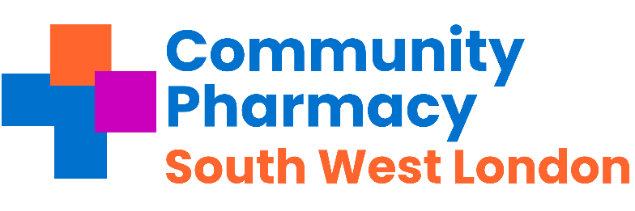

Pharmacies across Southwest London - important messages to share with your teams this week and any necessary actions.
Subject | Requirement | Deadline | Action and links | Tick when completed
Easter Rota | Contractual | April | The Easter Bank Holiday opening times for London are now available on the LPC Website here  - View the CPE briefing here  - View the Focus on Methadone video here  - View the Opioid Treatment Bank Holiday Checklist here
End of month prescription declaration | Contractual | Before 5th April | Pharmacy owners will need to take particular care to submit their declarations on time in order secure early advance payment on 10th April 2026. See more information here.
LPC contractor survey on CPCF services | Support | 10th April | Please complete the contractor feedback on services  - Sutton Contractor survey (this is separate due to collaboration with Sutton GP Federation  - SW LONDON COMMUNITY PHARMACY CPCF SERVICE SCOPING.
Pharmacy First | Pharmacy Income | March | The activity threshold of clinical pathway consultations is 30 per month. This means you need to provide a minimum of 30 consultations that pass the gateway point to be eligible for the  £1,000 monthly payment (or 20+ for £500).  Check the NHSBSA website to see what your Pharmacy First cap is for this month.
CPE Pressure Survey | CPE information required | 13th  April  2026 | CPE Pharmacy Pressures Survey deadline has been extended to 10am on Monday 13th April 2026 and are keen to hear from all pharmacy owners and staff  Take part and find out more here
Lateral Flow Device (LFD) Myth busting Series | Contractual | Available Now | View the series that tackles some the misconceptions around the LFD service View here
Pharmacy First | Contractual | April 2026 | Updated Pharmacy First caps come into force for April 2026  Action: check NHSBSA website to see what your cap is for this month
COVID-19 Vaccination Service | Contractual | 13th April – 30th June 2026 | - Manage Your Service (MYS) will be available for registration and de-registration for both Covid-19 and Flu services  - New joint service specification for COVID-19 and adult flu vaccinations published  - Distance selling pharmacies (DSP) are no longer able to offer the administration of COVID-19 (and Flu) vaccinations on the premises as part of the Advanced, National Enhanced or Enhanced service  - Download the Spring 2026 Covid-19 PGD here  Find out more here
Flu Vaccination Programme | Contractual | 31st Mar 2026 | - 31st March – Flu season ends. Also last day for National Booking Service (NBS) booked appointments for flu vaccinations  - ACTION: At the end of the day remove any promotional materials for the Flu Vaccination Service (including any on your website) and ensure all staff are aware that the service has now finished for 2025/26  Find out more here
Annual Complaints Report | Contractual | April | Make sure information is collated and ready to submit. The ICB will provide details on how to submit.

Regular Tasks The following tasks need to be completed on a daily / monthly basis:
Subject | Requirement | Deadline | Action and links | Tick when completed
Service payment claim tracker | Pharmacy income | Monthly | Community Pharmacy England has created a payment timetable and deadline tracker to assist pharmacy owners with checking and claiming payments for the following services: The link is here
Reminder  Pharmacy First -Thresholds | Pharmacy Income | Monthly | - £500 for those providing 20-29 Clinical pathways consultations within a month; and  - £1000 for those pharmacies that provide 30 or more Clinical pathways consultations within a month.  Check activity early in week 3 or 4 of each month.
Check NHS Shared Mailbox | Pharmacy Business | Twice a day -minimum | NHSE&I and CPSC regularly send important communications to your NHS Shared Mailbox.  Please ensure at least 2 members of staff have access your Mailbox and that it is checked at least twice a day.  Please see advice here.
Online Profile Update using NHS Profile Manager | Contractual | Quarterly | Using the ,NHS Profile Manager ensure your Directory of Services (DoS) and NHS website pharmacy profiles are up to date. This needs to be verified each quarter. Remember to update your profile if you have to temporarily close the pharmacy during its normal hours.
Local Services | Payments | By the 5th of each month | Please claim all your locally commissioned services.
PharmOutcomes Access | Information & Support | Now | Check that pharmacy staff have access to PharmOutcomes during all opening times, especially when locums are on duty; set-up additional accounts if needed. Instructions can be found here.’ Please ensure PharmOutcomes is checked regularly throughout the day (minimum 3 times a day) and action any referrals received for the following services:  - The Pharmacy First Service  - The Discharge Medicines Service  - The Hypertension Case Finding  - The Contraception Service  - The Smoking Cessation service
Serious Shortage Protocols (SSPs) | Dispensing | Ongoing | Active SSPs Can be found here.
MHRA Drug Safety  Newsletter | Dispensing | Monthly | Download the monthly newsletter here
Drug Tariff | Dispensing | Monthly | Updates on the drug tariff can be found here
LPC email distribution list and LPC borough WhatsApp group | Communications |  | The LPC encourages Contractors, Pharmacy Superintendents , responsible pharmacy managers and locums to join the LPC mailing list to ensure they are up to date with the changes.

Annual national campaigns for all national campaigns including health campaigns – please go here Note these events are not contractual.

Health Campaigns for April 2026
Stress Awareness Month | April | Increasing public awareness about both the causes and cures for our modern stress epidemic.  Stress Management Society  Supporting our NHS people

