y
Community Pharmacy Tracker and key tasks
February 2026
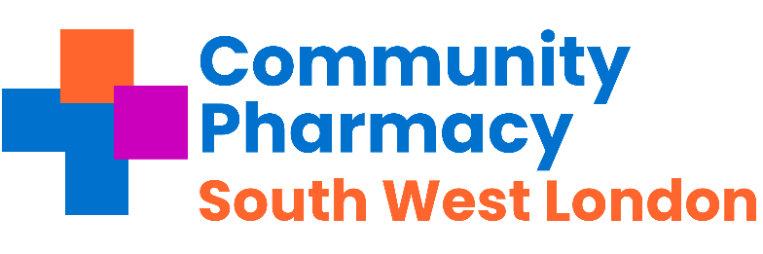

Pharmacies across Southwest London - important messages to share with your teams this week and any necessary actions.
Subject | Requirement | Deadline | Action and links | Tick when completed
Pharmacy Quality Scheme 2025/26 declaration | MYS – Claims must be made | between 9am on 2nd February 2026 and 11.59pm on 27th February 2026 | Please check the CPE Service payment tracker here , Pllaese attachment X  Links  - Community Pharmacy England – PQS FAQs  - Community Pharmacy England – Manage Your Service (MYS) application page – Includes FAQs on MYS  - CPPE – PQS webpage  - NHSBSA – Manage Your Service (MYS)  - NHSBSA – Manage Your Service (MYS) portal  - NHSBSA – Pharmacy Quality Scheme  Key Points:  - Claimed via MYS between 9am, 1 May 2025 and 11:59pm, 16 May 2025.  - Paid on 1 July 2025.  - Maximum claim is 75% of total available points.  - Value per point is £57.50 (minimum PQS point value).  - Submissions must be completed and submitted in MYS—incomplete declarations are not eligible.  - A confirmation email is sent after submission and should be kept as proof. If not received within 1 hour, email: pharmacysupport@nhsbsa.nhs.uk.
PQS: The  Antimicrobial Stewardship | Contractual | 1st Sept 2025 – 31st  Mar 2026 | Pharmacy First consultations clinical audit can be started from the 1st September 2025  The 2025/26 clinical audit should be conducted from 1st September 2025 and completed no later than 31st March 2026
Pharmacy Quality Scheme | Pharmacy Income | 3rd February | - Sore Throat Audit – Last day to start the audit to be able to complete by 31st March
National Health Campaign | Contractual | 2nd February – 22nd February | Mandatory The second national health campaign promoting Pharmacy First. Please see CPE guidance .
Lateral Flow Device (LFD) Myth busting Series | Contractual | Available Now | View the series that tackles some the misconceptions around the LFD service View here
Category H guidance | Income | February | Please read the guidance on Category H and sign up for the webinar on 16th February Register for the Category H webinar.
Pharmacy First | Contractual | 1st January 2026 | Updated Pharmacy First caps come into force for January 2026  Action: If not already done so, check NHSBSA website to see what your Pharmacy First cap is for this month
Oriel Registration for 27/28 | Information & Support | 3rd March | Pharmacies need to register on Oriel if you want to host a trainee pharmacist for 27/28. More information

Regular Tasks The following tasks need to be completed on a daily / monthly basis:
Subject | Requirement | Deadline | Action and links | Tick when completed
Service payment claim tracker | Pharmacy income | Monthly | Community Pharmacy England has created a payment timetable and deadline tracker to assist pharmacy owners with checking and claiming payments for the following services: The link is here
Reminder  Pharmacy First -Thresholds | Pharmacy Income | Monthly | - £500 for those providing 20-29 Clinical pathways consultations within a month; and  - £1000 for those pharmacies that provide 30 or more Clinical pathways consultations within a month.  Check activity early in week 3 or 4 of each month.
Check NHS Shared Mailbox | Pharmacy Business | Twice a day -minimum | NHSE&I and CPSC regularly send important communications to your NHS Shared Mailbox.  Please ensure at least 2 members of staff have access your Mailbox and that it is checked at least twice a day.  Please see advice here.
Online Profile Update using NHS Profile Manager | Contractual | Quarterly | Using the ,NHS Profile Manager ensure your Directory of Services (DoS) and NHS website pharmacy profiles are up to date. This needs to be verified each quarter. Remember to update your profile if you have to temporarily close the pharmacy during its normal hours.
Local Services | Payments | By the 5th of each month | Please claim all your locally commissioned services.
PharmOutcomes Access | Information & Support | Now | Check that pharmacy staff have access to PharmOutcomes during all opening times, especially when locums are on duty; set-up additional accounts if needed. Instructions can be found here.’ Please ensure PharmOutcomes is checked regularly throughout the day (minimum 3 times a day) and action any referrals received for the following services:  - The Pharmacy First Service  - The Discharge Medicines Service  - The Hypertension Case Finding  - The Contraception Service  - The Smoking Cessation service
Serious Shortage Protocols (SSPs) | Dispensing | Ongoing | Active SSPs Can be found here.
MHRA Drug Safety  Newsletter | Dispensing | Monthly | Download the monthly newsletter here
Drug Tariff | Dispensing | Monthly | Updates on the drug tariff can be found here
LPC email distribution list and LPC borough WhatsApp group | Communications |  | The LPC encourages Contractors, Pharmacy Superintendents , responsible pharmacy managers and locums to join the LPC mailing list to ensure they are up to date with the changes.

Annual national campaigns for all national campaigns including health campaigns – please go here

Health Campaigns for January- February 2026
Heart month | February | This Heart Month learn about cholesterol and adjust your lifestyle for a healthy heart  Heart Month
World Cancer Day | 4 February 2026 | Aims to save millions of preventable deaths each year by encouraging individuals to take action.  World Cancer Day
Time To Talk Day | 6 February 2026 | Getting people to talk about mental health and by doing so help change lives.  Time to Change Suicide prevention
Eating Disorder Awareness Week | 23 February - 1 March 2026 | An international awareness event, fighting the myths and misunderstandings that surround eating disorders.  Beat Eating Disorders
Rare disease day | 28 February 2026 | Rare disease day is a patient led day to working towards equality in healthcare, diagnosis and therapies  Rare disease day

