y
Community Pharmacy Tracker and key tasks
December 2025

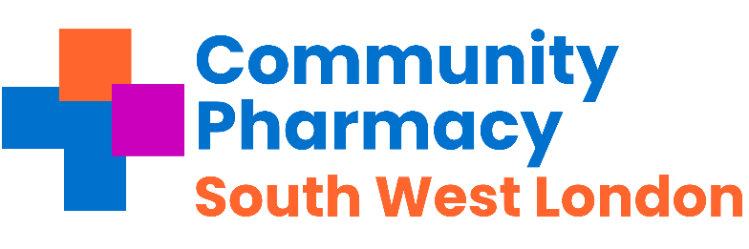

Pharmacies across Southwest London - important messages to share with your teams this week and any necessary actions.
Subject | Requirement | Deadline | Action and links | Tick when completed
Reminder  Pharmacy First -Thresholds | Pharmacy Income | Monthly | - £500 for those providing 20-29 Clinical pathways consultations within a month; and  - £1000 for those pharmacies that provide 30 or more Clinical pathways consultations within a month.  Check activity early in week 3 or 4 of each month.
Christmas and new year rota. | Contractual | Now | The London DOP team has sent out the Christmas and Holiday new year Rota, which is saved as attachment 6 Please make sure this is displayed on your doors and windows for the public.
PQS: The  Antimicrobial Stewardship | Contractual | 1st Sept 2025 – 31st  Mar 2026 | Pharmacy First consultations clinical audit can be started from the 1st September 2025  - The 2025/26 clinical audit should be conducted from 1st September 2025 and completed no later than 31st March 2026
Pharmacy First | Contractual | 1st December 2025 | Updated Pharmacy First caps come into force for December 2025  - Action: If not already done so, check NHSBSA website to see what your Pharmacy First cap is for this month
Lateral Flow Device (LFD) Myth busting Series | Contractual | Available Now | View the series that tackles some the misconceptions around the LFD service View here
Flu Vaccination Service | Contractual | End of November | NHS England anticipate that most flu vaccinations should be completed by the end November 2025 to provide the best possible protection going into winter. Find out more here
COVID-19 | Contractual | 19th December 2025 | NHS England anticipate that most COVID-19 vaccinations should be completed by this date  Find out more here

Regular Tasks The following tasks need to be completed on a daily / monthly basis:
Subject | Requirement | Deadline | Action and links | Tick when completed
Reminder  Pharmacy First -Thresholds | Pharmacy Income | Monthly | - £500 for those providing 20-29 Clinical pathways consultations within a month; and  - £1000 for those pharmacies that provide 30 or more Clinical pathways consultations within a month.  Check activity early in week 3 or 4 of each month.
Check NHS Shared Mailbox | Pharmacy Business | Twice a day -minimum | NHSE&I and CPSC regularly send important communications to your NHS Shared Mailbox.  Please ensure at least 2 members of staff have access your Mailbox and that it is checked at least twice a day.  Please see advice here.
Online Profile Update using NHS Profile Manager | Contractual | Quarterly | Using the ,NHS Profile Manager ensure your Directory of Services (DoS) and NHS website pharmacy profiles are up to date. This needs to be verified each quarter. Remember to update your profile if you have to temporarily close the pharmacy during its normal hours.
Local Services | Payments | By the 5th of each month | Please claim all your locally commissioned services.
PharmOutcomes Access | Information & Support | Now | Check that pharmacy staff have access to PharmOutcomes during all opening times, especially when locums are on duty; set-up additional accounts if needed. Instructions can be found here.’ Please ensure PharmOutcomes is checked regularly throughout the day (minimum 3 times a day) and action any referrals received for the following services:  - The Pharmacy First Service  - The Discharge Medicines Service  - The Hypertension Case Finding  - The Contraception Service  - The Smoking Cessation service
Serious Shortage Protocols (SSPs) | Dispensing | Ongoing | Active SSPs Can be found here.
MHRA Drug Safety  Newsletter | Dispensing | Monthly | Download the monthly newsletter here
Drug Tariff | Dispensing | Monthly | Updates on the drug tariff can be found here
LPC email distribution list and LPC borough WhatsApp group | Communications |  | The LPC encourages Contractors, Pharmacy Superintendents , responsible pharmacy managers and locums to join the LPC mailing list to ensure they are up to date with the changes.

