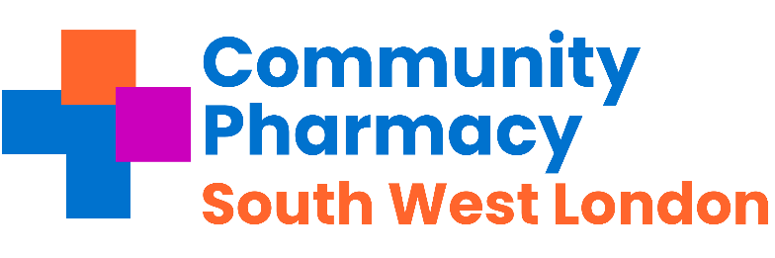

**COMMUNITY PHARMACY SOUTH WEST LONDON**

**ANNUAL GENERAL MEETING**

18th September 2024

***The Grange, Beddington Park, London Road, Wallington, SM6 7BT***

AGENDA

|  |  |  |
| --- | --- | --- |
| 7.15 pm | Dinner |  |
| 8.00 | Welcome and apologies | Mayank Patel |
|  | Pre-recorded presentation from Community Pharmacy England | James Wood Director of Member & LPC Support  David Webb Chief Pharmacy Officer for England |
| 8.15 | Presentation from the Independent Pharmacy Association | Leyla Hannbeck |
| 8.35 | Introduction & Highlights of Business Fundamentals for Pharmacist session in November | Shanee Baker |
| 9:00 | Our year -And Transition to Community Pharmacy South West London | Mayank Patel/Amit Patel |
| 9.10 | Questions and presentation of Accounts | Mansukh Sheth |
| 9.20 | Vote | LPC Executive |
| 9.30 pm | Close and thank you |  |

**Event sponsored by:**

[](https://gbr01.safelinks.protection.outlook.com/?url=http%3A%2F%2Fwww.exeltis.com%2F&data=05%7C02%7China.patel19%40nhs.net%7C8a2c8dc371a54d07ab2708dcd3e53500%7C37c354b285b047f5b22207b48d774ee3%7C0%7C0%7C638618228624127360%7CUnknown%7CTWFpbGZsb3d8eyJWIjoiMC4wLjAwMDAiLCJQIjoiV2luMzIiLCJBTiI6Ik1haWwiLCJXVCI6Mn0%3D%7C0%7C%7C%7C&sdata=H07lGte3GHvoFiQnmkyOJ9RGMtvSzlSG4mdkkc0NT7I%3D&reserved=0)

Supporting this meeting by paying a sponsorship fee but has no input into the meeting agenda or content.