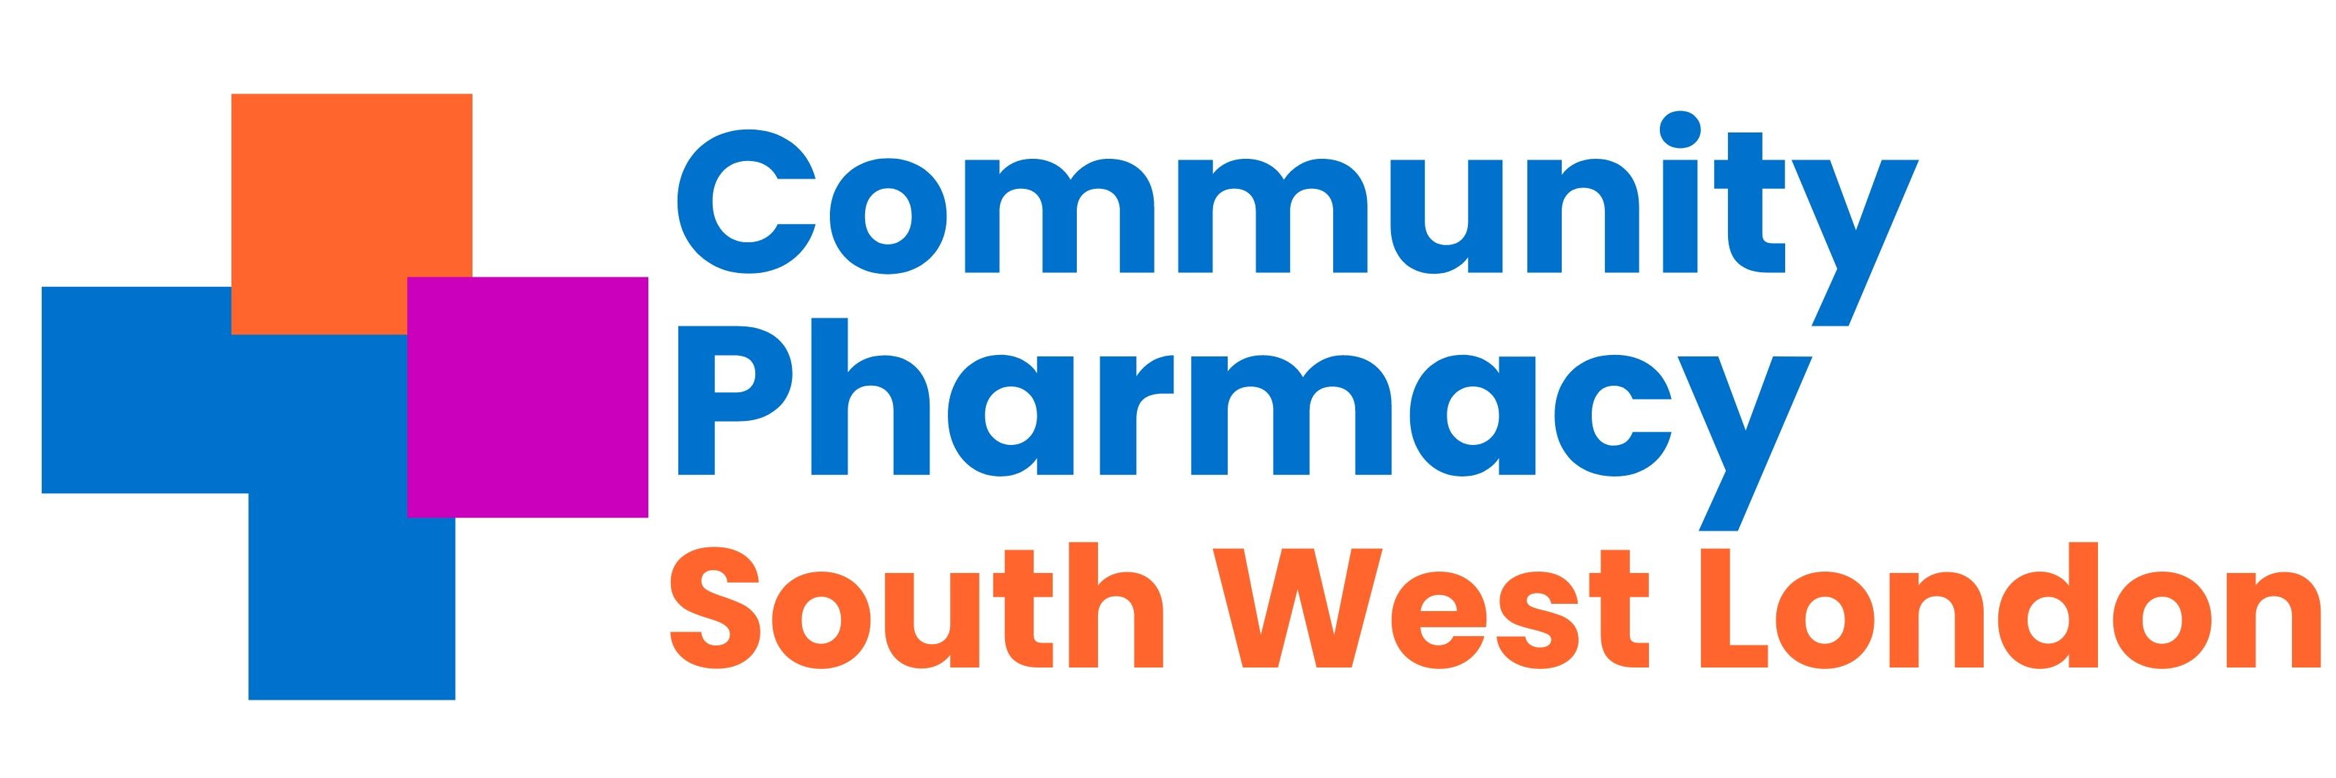

Community Pharmacy South West London Smoking Cessation Service

MDT Meeting

Date: | Wednesday 17th April
Time: | 8.00pm-9.00pm
Venue: | Virtual - Click here to join the meeting

No. | Section | Lead | Timing | Presentation | Action Required
1. | Welcome & Introductions | AP | 8.00-8.05
2. | Service overview  - CP requirements to deliver the service | DTR/DT | 8.05-8.10
3. | SWL Acute Trusts live on SCS | NR | 8.10-8.15
4. | Two Case studies  - CP challenges and best practice sharing |  | 8.15-8.35
5. | Actual Service Delivery: top tips and hints | DTR/NR | 8.35-8.50
6. | AOB & Next steps | All | 8.50-9.00

